Title of Your Research

First Name Last Name¹, First Name Last Name², First Name Last Name*,³
(Presenting Author, *Corresponding Author)
¹Affiliation, City, Country
²Affiliation, City, Country
³Affiliation, City, Country
*E-mail: corresponding.author@email.com

Abstracts must be written in English and should not exceed 100 words. Texts of the abstract must be single spaced in Arial, font size 10 and both left and right justified. Submit your abstract in .doc or .docx file formats in the abstract submission at https://isvsp2024.sciencesconf.org/.

Introduction
Briefly introduce the research problem, context, and objectives. All contributed papers must be written in English and present original research. The total length—including figures and references—must not exceed two A4 pages. Invited speakers are also required to submit a two-page summary of their presentation in the same format.
Authors are fully responsible for the content and formatting of their submissions. Submitted papers will be published exactly as received, without any modifications or reductions. Submissions that do not adhere to the specified format may be rejected. Abstracts must be submitted online via the official ISVSP2026 website. All files must be in Portable Document Format (PDF). Authors using Microsoft Word or LaTeX should convert their documents to PDF before submission.
Each contributed paper should include the following sections:
- Introduction
- Materials and Methods
- Results and Discussion
- Conclusion
Optional sections such as Acknowledgements and References may be added after the Conclusion.

Materials and Methods
Summarize the methodology, experimental setup, or theoretical framework used. Keep it concise but informative.

Results and Discussion
Highlight key findings with brief interpretation. You may include one figure or table if space allows (minimum resolution: 150 dpi). Ensure captions are in Arial 10 pt, centered.

  - Figures and Tables
Figures may be included in the abstract. Since the proceedings will be printed in black and white, it is recommended to use monochrome figures for clarity. Each figure must include a caption positioned directly below it. Examples of proper formatting for figures and tables are shown below:

Fig 1. You may include figures if the minimum resolution is 150 pixels/inch.

Table 1 Example table for the paper.
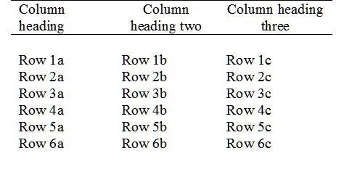

  - Equations
Equations should be indented from the left margin. Each equation must be numbered, with the number enclosed in parentheses and aligned to the right margin of the column (flush right). An example is shown below
. (1)

Conclusion
Summarize the main outcomes and potential implications. Keep this section short and impactful. List and number all references at the end of the paper. When referring to them in the text, type the corresponding reference number between brackets as shown at the end of this sentence [1].

Acknowledgment
The authors would like to thank [Funding Agency] for support [Project Number XXXXXXX].

References
[1] A. Author, B. Author, Journal Name, Year, Volume, Pages.
[2] A. Author, "Conference Title", Conference Name, Venue, Year.

